PABALLO MARY MOKOENA

MODUDLE NAME: WED DEVELOPMENTSTUDENT NO:ST10501151GROUP ONEDNM0601WEB DEVELOPMENT PROPOSAL
  - [Document subtitle]

Table of Content
Contents
3.1 Organisation Overview 1
The website will therefore contain the following main pages: 1
Pabii’s Retreat website will use the following structure. 2
1.Homepage-indx.html 4
2.About Us-about.html 4
3.Services/ Packages- services.html 4
4. Package Details- packages.html 5
5. Gallery- gallery.html 7
6. Enquiry- enquiry.html 7
7. Contact Us – contact.html 8
References 11

README.md link: https://github.com/Pabii96/Pabii-Retreat---.git
3. Content Research and Sourcing- Pabii’s Retreat

3.1 Organisation Overview
Pabii Massage Parlour Wellness Sanctuary wad founded by Paballo in July 2026, was created and dedicated with the vision of helping clients to restore their balance, relieve stress and improve their overall health. It was established to deliver the needs of clients after the recognition that a lot of people suffer from stress, fatigue, muscle tension and the pressure of life. The massage parlour will ensure that it offers different range of therapeutic services that will includes hot stone therapy, facial treatment, Swedish massage, full body massage and more.
Main reason of establishing Pabii’s Retreat was to provide affordable, high-quality services to motivate people to prioritise their health, promote their physical and mental wellness in a calm and comfortable environment.

The website will therefore contain the following main pages:
- Homepage
- About Us
- Services
- Packages
- Gallery
- Customer Reviews
- Enquiries
- Contact Us
Website Structure and Planning
4.1 Sitemap- Pabii’s Retreat
- The Retreat sitemap provides visitors will access to information about the organization, wellness services, the packages, gallery, enquiries, customer reviews and contact information.
- The provided structure helps customers find suitable treatments, be able to have a refreshing environment and make enquiries or spa bookings efficiently.

Pabii’s Retreat website will use the following structure.

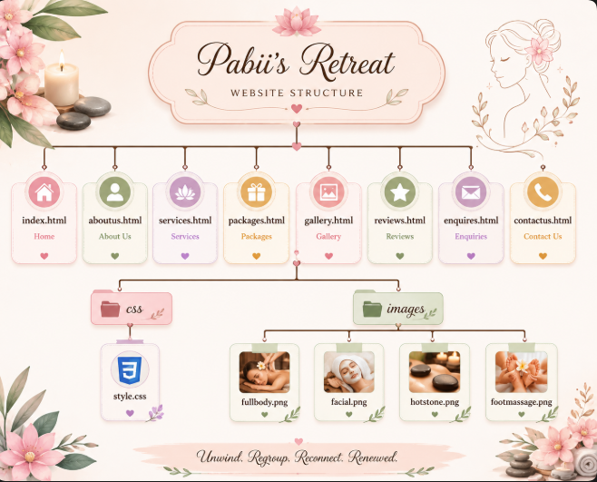
Figure 4 image created in Canva

PABII’S RETREAT

1.Homepage-indx.html
Welcome to Pabii’s Retreat
- Unwind. Regroup. Reconnect. Renewed
Our retreat spa offers personalized treatment and therapeutic treatment for its customers to able to unwind, calm their minds, relax the bodies, be flexible and mostly have a healthy lifestyle.

2.About Us-about.html
Pabii’s Retreat is a customised spa and therapeutic treatment that provides its clients a personalised wellness experience that is designed to remove them from everyday life and promotes relaxation and improving long lasting wellness.
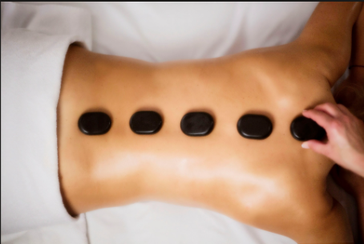
Mission
We aim to provide exceptional and personalised therapy that calms the mind, relax the body, lift the spirit and mostly creating a lasting sense of well-being to our clients.
Vision
Our aim is to become a respected, leading and reputable centre of excellence by providing clinically rehabilitation centre.

3.Services/ Packages- services.html
Packages include
- Welcome juice
- 45 mins Full Body Massage
- Lunch and coffee/juice all this luxury for R600.
- Welcome juice
- Facial Treatment for R200
- 30 mins Full Body Massage
- 15 mins backstone therapy
- 15 mins facial treatment all for R350
NB-And additional services to offer

4. Package Details- packages.html
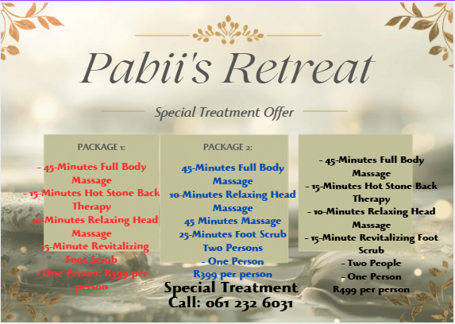
Figure 5 Image created on Canva

5. Gallery- gallery.html
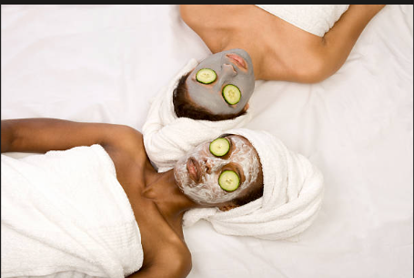
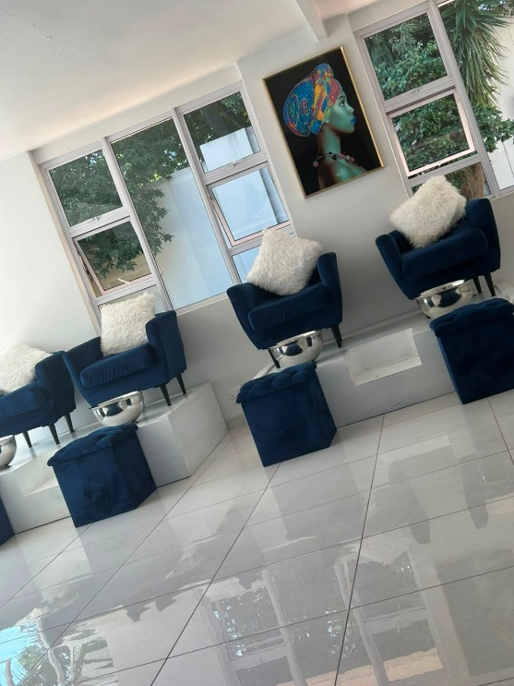

6. Enquiry- enquiry.html
Complete the form below to enquire about our services or request a spa appointment. Our team will respond with availability and further information.
- Booking Policies: Required non-refundable deposit of 30% to confirm your appointment
- Late fee required after 30 minutes grace period.
Enquiry form
Personal information:
- Full Name
- Email Address
- Phone Number
Appointment information:
- Preferred Date
- Preferred Time
- Preferred Treatment
- Number of People
Additional requirements:
- Special requests
- Questions
- Preferred therapist, if applicable

7. Contact Us – contact.html
Information to include
- Phone:
061 232 6031
- Email:
pabii’s@retreatspa.co.za
Address:
195/11907 Msilinga Street
Pimville Zone 9
1809
- Business hours:
Monday- Friday-9am- 6pm
- Saturday-8am- 1pm
- Sundays closed
- Public holidays open upon request
Contact form
- Full Name
- Email
- Phone
- Subject
- Message
- Submit button
Location
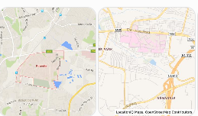
8. Customer Reviews- reviews.html
As Pabii’s Retreat is a new business that started operating in July, it doesn’t currently have an existing customer review yet as we are still promoting the business using family and friends.
9. Social media
As Pabii’s Retreat is a newly formed business it hasn’t yet established social media yet as it was launched in July 2026. Social media has been spoken about as any important marketing platform. This social media platform will assist in promoting the business.
3.Content Research and Sourcing
- Organisation’s Website (if applicable)
Pabii’s Retreat was established in July 2026 as a new business, it currently has limited existing as we were using WhatsApp to promote the business to our friends, family and close neighbours. The proposed websites will be established to attract customers and provide them with important information about the Retreat.
- Social Media:
As Pabii’s Retreat is a newly formed business it hasn’t yet established social media yet as it was launched in July 2026. Social media has been spoken about as any important marketing platform. This social media platform will assist in promoting the business
- Public Domain and Creative Commons Resources: Pabii’s Retreat will use public domain and creative that will be suitable for the organization that will display resources such as wellness, nature etc.

References
American Massage Therapy Association (AMTA). 2024. Massage Therapy Research and Consumer Information. Online. Available at: https://www.amtamassage.org/ [Accessed 25 July 2026].
aromatherapy massage - Search Images
body massage stone - Search Images
Creative Commons. 2026. Sharing openly, sharing globally. Available at: Creative Commons – Sharing Openly, Sharing Globally (Accessed 02 August 2026). Creative Commons
Creative Commons. 2026. Attribution. Available at: Creative Commons – Attribution (Accessed 02 August 2026).
Hot Stone Massage black african - Search Images
Sharpsheets. 2026. SWOT Analysis for a Massage Therapy Business. Online. Available at: https://sharpsheets.io/blog/swot-analysis-massage-therapy-business/ [Accessed 25 July 2026].
spa parlour logo for a new business called Pabii's Retreat - Search
spa images difference treatment black african - Search Images
types of spa treatments black african, facial,foot,body,swidish - Search Images
World Health Organization (WHO). 2026. Self-care for health and well-being. Available at: WHO – Self-care for health and well-being (Accessed 02 August 2026).

README.md link: https://github.com/Pabii96/Pabii-Retreat---.git

